ASSIGNMENT - 4

|  |  |
| --- | --- |
| Assignment Date | 15 October 2022 |
| Student Name | Sadhana M |
| Student Roll Number | 720719104140 |
| Maximum Marks | 2 Marks |

**Dataset**: [https://drive.google.com/file/d/1sIv7x7CE0zAPAt0Uv6pbO2ST2LVp5u/view](https://drive.google.com/file/d/1sIv-7x7CE0zAPAt0Uv-6pbO2ST2LVp5u/view)

**Loading the dataset:**

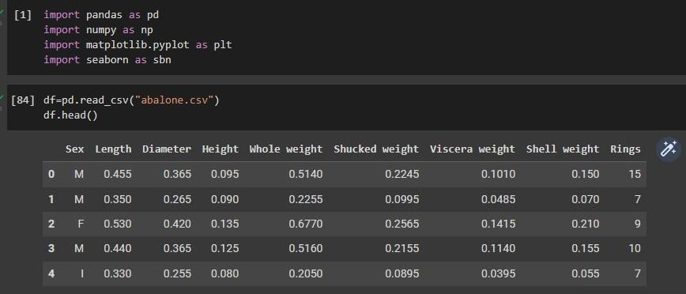

**Perform Below Visualizations.**

**∙ Univariate Analysis**

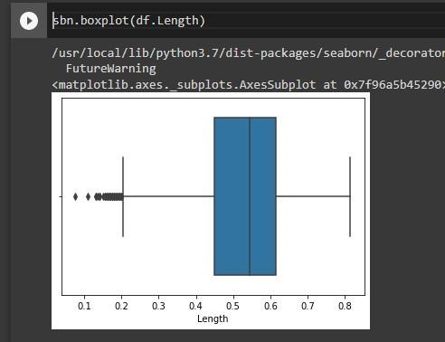

**Bi-Variate Analysis**

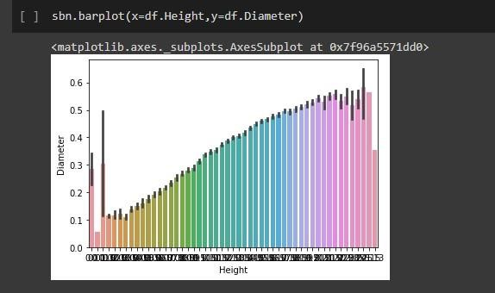

**Multi-Variate Analysis**

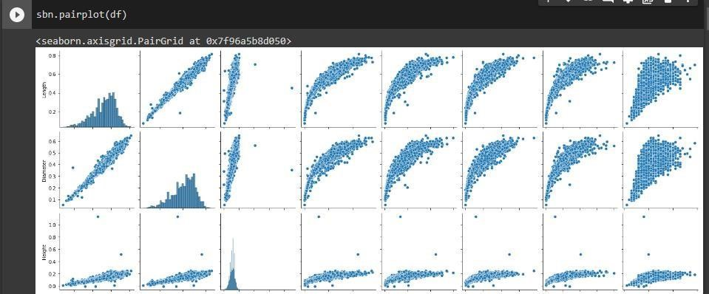

# Perform descriptive analytics on the dataset

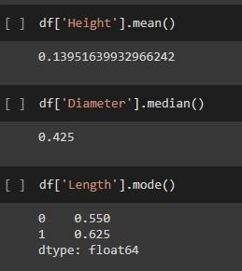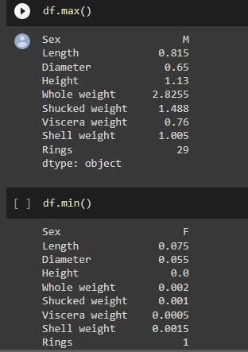

**Check for Missing values and deal with them.**

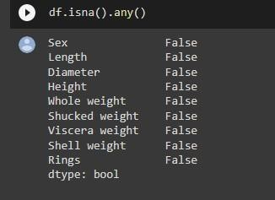

# Find the outliers and replace them outliers

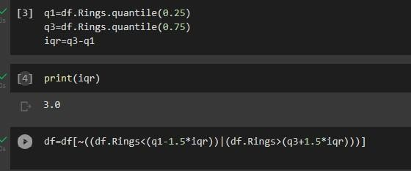

**Check for Categorical columns and perform encoding.**

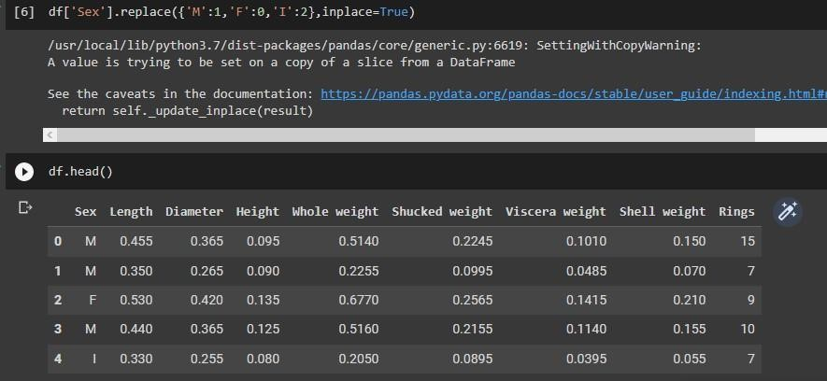

**Split the data into dependent and independent variables.**

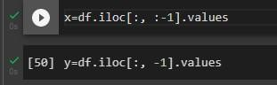

# Scale the independent variables

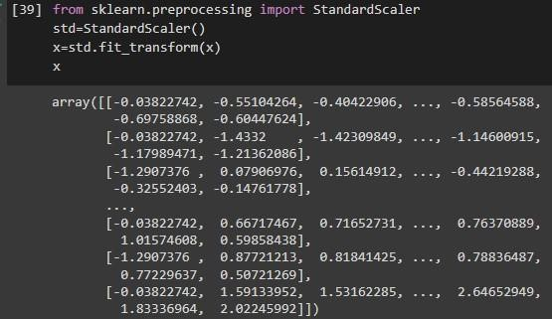

# Split the data into training and testing

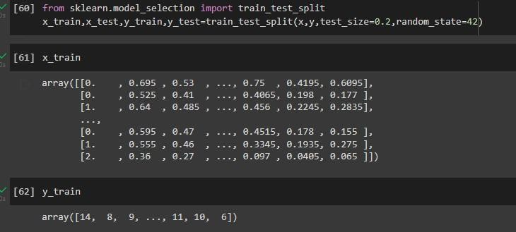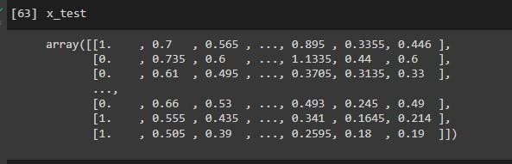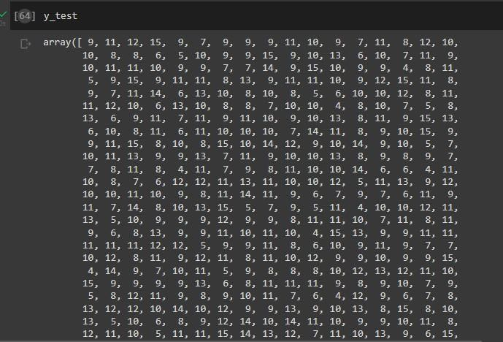

# Build the Model

from sklearn.ensemble import RandomForestRegressor model =

RandomForestRegressor(n_estimators = 1000, oob_score =

True,n_jobs=1,min_samples_split = 6, min_samples_leaf= 4, max_features = 'sqrt', max_depth= 120, bootstrap=True)



# Train the Model

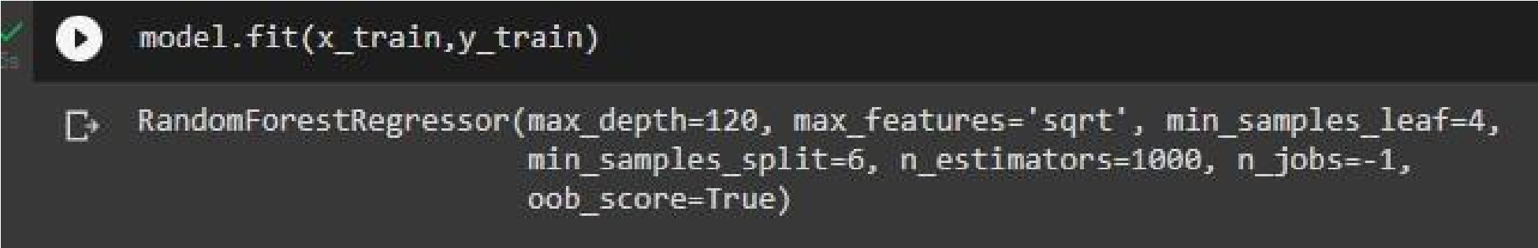

# Test the Model

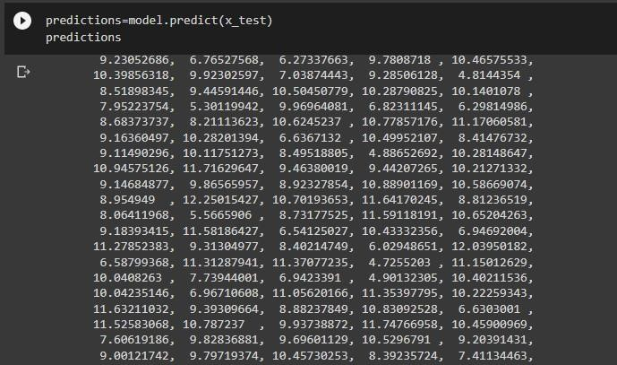

**Measure the performance using Metrics.**

